Practical 5
Code:https://github.com/bhavyakumar18/DSA/tree/main/Practical%205
Problem 1, I faced problems in correctly connecting the prev and next pointers while inserting or deleting songs, especially when the playlist had only one song or when inserting at the end. I solved this by updating both forward and backward links and separately handling empty and single-node cases. If the required song is not found, the list remains unchanged.
Output:
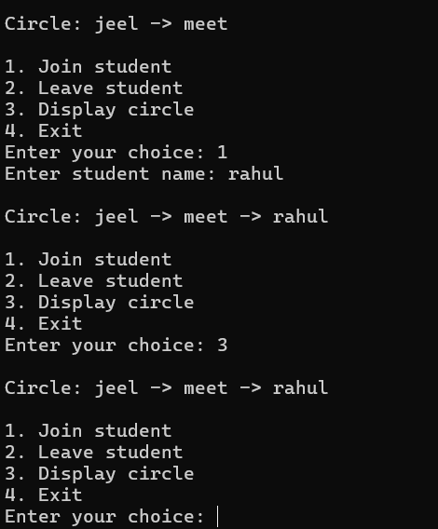

Problem 2, the main problem was keeping the circular list connected after a student leaves, especially when there is only one student. I solved this by connecting the previous node directly to the next node, and in the doubly circular list updating both next and prev pointers. For the single-student case, I set the list to nullptr so the circle does not become broken.
Output:


